**Project Report: Explore Weather Trends**

**Contents:**

1. Steps Outline
2. Line Chart : Local and Global Temperature Trends
3. Observations

**Steps Outline:**

**Tools Used** – SQL, EXCEL

Following steps were performed in given sequence.

1. Extracted weather data of city (New Delhi) in a csv **(Tool - SQL)**

* SELECT * FROM city_data WHERE city = 'New Delhi' and country = 'India'

1. Found the oldest and latest year in which temperature was recorded in New Delhi. **(Tool – SQL)**

* SELECT year FROM city_data WHERE city = 'New Delhi' and country = 'India' ORDER BY year DESC LIMIT 1
* SELECT year FROM city_data WHERE city = 'New Delhi' and country = 'India' ORDER BY year ASC LIMIT 1

1. Extracted global weather data with the previously calculated max and min year, so that moving averages could be calculated in similar time frame. **(Tool - SQL)**

* SELECT * from global_data WHERE year >= 1796 AND year <= 2013

1. Calculated the moving average using Excel by Formula, **=AVERAGE(Col1: Col2). (Tool - EXCEL)**
2. Imputed missing local weather data, replaced the missing value with previous moving average till that point. **(TOOL - EXCEL)**
3. Plotted line chart for both data sets. **(TOOL - EXCEL)**
4. Started drawing conclusions.

Key Considerations for visualization:

1. Replace missing data.
2. Since, data is time series, so line charts or scatter plots could represent it beautifully.
3. The expected data is numerical in nature.

**Line Chart (New Delhi vs Global Weather)**

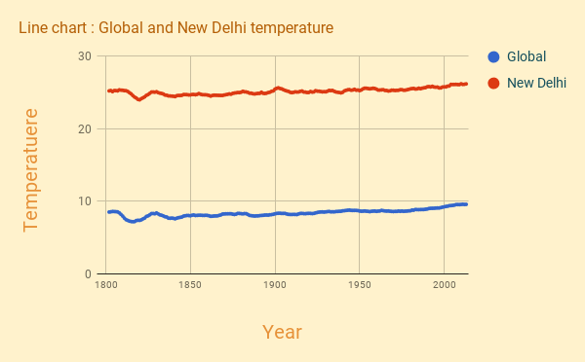

**Observations**

**Question 1)** is your city hotter or cooler on average compared to the global average? Has the difference been consistent over time?

Solution: New Delhi, is hotter on average compared to the global average, Line chart in previous page communicates the same very clearly. Also, the difference between the moving averages of New Delhi and Global Weather, is quite consistent over time, the difference ranging between, 16 – 18 C.

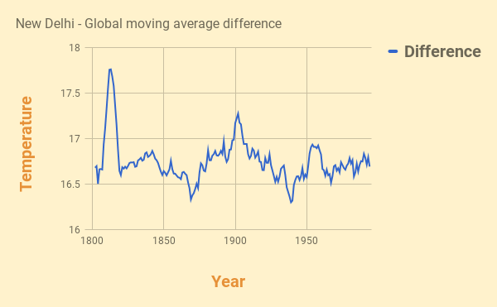

**Question 2)** how do the changes in your city’s temperatures over time compare to the changes in the global average?

The changes in New Delhi’s and global temperatures (Difference in subsequent moving average) over time, is almost similar, below attached line chart for the same. It looks almost equal. The moving average difference from the previous moving average in both of the scenarios, deviates between +0.3 to – 0.3.

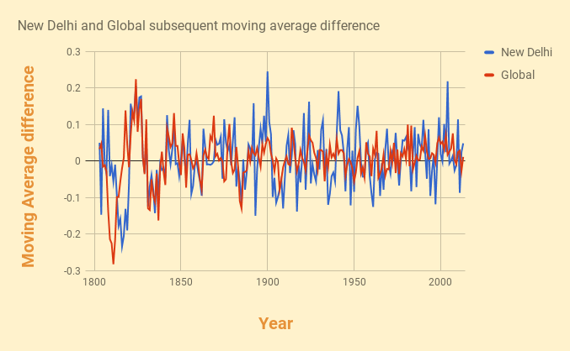

* **Question 3)** is the world getting hotter or cooler? Has the trend been consistent over the last few hundred years?

The world is getting hotter since 1920, First half of 19th century was less consistent with moving average deviating from 7 – 8.5, the second half of 19th century had moving average maximum consistent mostly between 8 – 8.5 till first quarter of 20th century, since then the moving average have jumped to 9 and the line chart is showing a clear incremental curve of it. 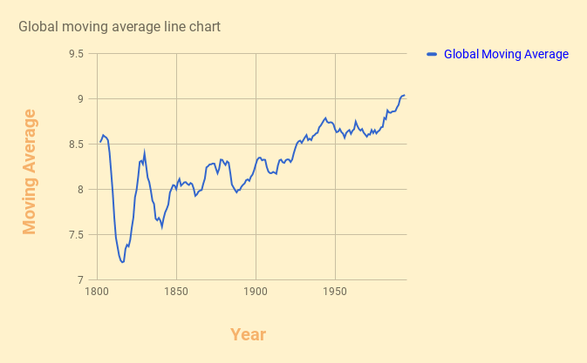

* **Question 4)** is New Delhi getting hotter or cooler?

Yes New Delhi is also getting hotter, the 20th century is clearly hotter than the 19th century, and we could also observe a steep curve in the end of 20th century.

